Computer Architecture Homework 4, Yu Liu(ID:801137940), Nov 19th, 2019.

* These files in the package are for problem 1 to problem4 in homework4.
* The source codes are under c language, including head are <stdio.h> , “stdbool.h” and <math.h>, can run under linux , unix, window 7 or above.
* Unzip the file of HW4_YULIU, put these files in one folder:
  + branchprd_yu.c
  + stdbool.h
  + branch-trace-gcc.trace
  + branches_0_dhrystone.out
  + branches_0_linpack.out
  + README.pdf

In the package files, below files are generated in the experiments for reference only:

* + generalInfo_0_dhrystone.out (this file is generated by pin tool)
  + generalInfo_0_linpack.out (this file is generated by pin tool)
  + branch_prediction.txt (this file is generated by the branchprd_yu.out)
* Below processes all run under linux as examples
* Any questions call my phone: +1 704 858 7806

This program will automatically detect the data type by checking the file postfix, the fetch the data according to the format and output the result by generating the file named branch_prediction.txt.

For all problems just follow the same steps as below:

1. Use file of “branchprd_yu.c”
2. Select the parameters and data file by revising the red word in “define” area:

#define FILENAME_INPUT "branches_0_dhrystone.out"

#define FILENAME_OUTPUT "branch_prediction.txt"

#define PREDICTOR_TYPE 'S' //upper case.O:one level, G:Global, S: Gshare, L: Two level local, H: Hybrid

#define PHT_SIZE 1024 //size of Local history register entry.Optionals: 256 (8 bits),128 (7 bits),64 (6 bits), 16(4 bits), 4(2 bits)

#define LHR_SIZE 128 //size of Local history register entry.Optionals: 1024(10 bits), 256 (8 bits),128 (7 bits),64 (6 bits), 16(4 bits), 4(2 bits)

#define GHR_BITS 10 //width of bit counter: optionals are 10,8,6,4,2

#define PC_SHIFT_BITS 5 // the last x bits of program counter to be ignored. options are 0,2,3,5

For example, we want to run branch-trace-gcc.trace under Two-Level Local predictor with 10 bits LHR and PC shit bits 3, then we can seting as below figure:

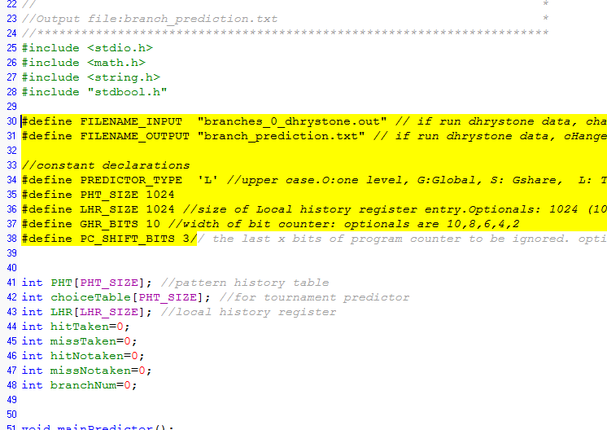

1. Compile file of branchprd_yu.c, use gcc command, add –lm for including <math.h>:

$ gcc branchprd_yu.c –o branchprd_yu.out –lm

1. Run

$ ./ branchprd_yu.out

1. Output data

A file named “r branch_prediction.txt” will be generated automatically (samples already listed). Open and read the data inside, sample as below figure.

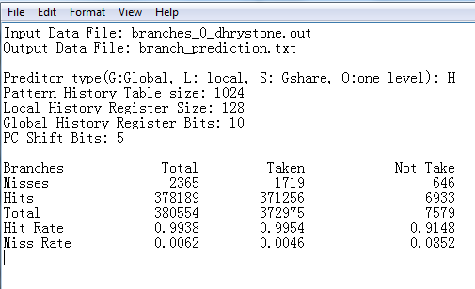

1. Done